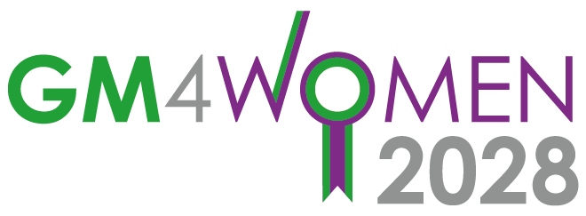 Website Briefing Template

This form is to help you brief the Comms team with the information they require to add
content on to the website.

Which part of the GM4Women2020 website do you see this content relating to :-
For example:-
Mind the Gap – Getting women’s Voices into Policy Making - info
Committee Section (Health / Safety / Work / Participation / Culture) | Produced by members of the Participation Committee
Blog | The publication is a series of blogs and available as an online publication at the link below
About Us
Events
Other suggestion

What priority / objective does this bit of content address?

The publication is both content from the participation committee and also is highly relevant to the post COVID-19 agenda

Are we to present this as a piece of content produced for/by GM4Women or are we promoting someone else’s work/content?

This publication was produced by members of the GM4Women2028 Participation Committee from the University of Manchester.

It would not have been possible without the ideas, experiences and enthusiasm of the campaigners, policy makers and researchers who attended the Getting Women’s Voices into Policymaking workshop held at The University of Manchester as part of the Economic and Social Research Council 2019 Festival of Social Science.

Getting women’s voices into policy making is vital. Mind the Gap – Getting Women’s Voices into Policy Making is a practical guide to making sure it happens. It brings together ideas and methods from researchers @uompolitics, campaigners @GM4women2028 and policy makers @greatermcr women’s voices task group.

It follows On Gender, a publication from Policy@Manchester also by researchers at the University of Manchester highlighting the importance of gender equality evidence within policymaking.

Both publications provide information that can be used to inspire and deliver women’s voices in politics and policy in Greater Manchester and beyond. Having an equalities evidence base and getting the full diversity of women’s voices into policy making is vital in building back better post COVID-19.

An online version of this publication contains links to the sources of evidence and further information cited in the publication. To view this version and see the links, visit: https:// www.socialsciences.manchester.ac.uk/connect/making-adifference/research-with-impact/

As well as thanks to the School of Social Science at The University of Manchester for funding assistance to run the workshop and produce this publication, we would like to acknowledge the support and participation of the members of the Greater Manchester Combined Authority Women’s Voices Task and Finish Group and the GM4Women2028 campaign.

What EXACT copy do you want displayed on the website (this can be sent as a separate attachment).

Anything from box above eg

NOTE: If you are sending a link or PDF of an article to point elsewhere, copy needs t be provided to introduce the article/event.

Provide a short paragraph of copy that will inform readers using the following questions as a guide:

- A headline
- What is the piece about?
- Why is GM4Women supporting / interested in it?
- What is the call to action?
- What image can go with it?

Mind the gap – Getting Women’s Voices into Policy Making

Getting women’s voices into policy making is vital. Mind the Gap – Getting Women’s Voices into Policy Making is a practical guide to making sure it happens. It brings together ideas and methods from researchers @uompolitics who are members of the GM4women2028 Participation Committee, campaigners @GM4women2028 and policy makers @greatermcr women’s voices task group.

It follows On Gender, a publication from Policy@Manchester also by researchers at the University of Manchester highlighting the importance of gender equality evidence within policymaking.

Both publications provide information that can be used to inspire and deliver women’s voices in politics and policy in Greater Manchester and beyond. Having an equalities evidence base and getting the full diversity of women’s voices into policy making is vital in building back better post COVID-19.

Do you have an image to use? (Please only supply imagery we have permission to use)

Will send attached

Are there any specific links we should include? (Have you signposted these in the summary copy you have provided?)

Yes hope so!

Are there any other organisations / individuals we should include / credit (please provide information)?

See above eg
As well as thanks to the School of Social Science at The University of Manchester for funding assistance to run the workshop and produce this publication, we would like to acknowledge the support and participation of the members of the Greater Manchester Combined Authority Women’s Voices Task and Finish Group and the GM4Women2028 campaign as well as other campaigners who contributed.

Do we need to get approval from any third parties before we publish the content live? (please provide details)

It is fine to point to the weblink for Mind the Gap

